<https://learn.microsoft.com/en-us/azure/key-vault/general/basic-concepts>

<https://testprep.cloudthat.com/mod/page/view.php?id=13773>

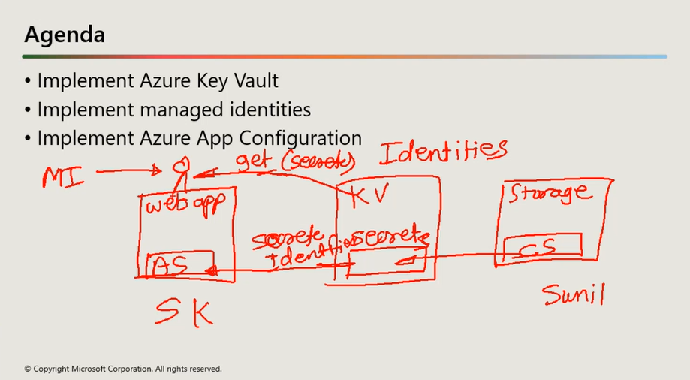

Azure Key Vault is a cloud service for securely storing and accessing secrets. A secret is anything that you want to tightly control access to, such as API keys, passwords, certificates, or cryptographic keys. Key Vault service supports two types of containers: vaults and managed hardware security module(HSM) pools. Vaults support storing software and HSM-backed keys, secrets, and certificates. Managed HSM pools only support HSM-backed keys.

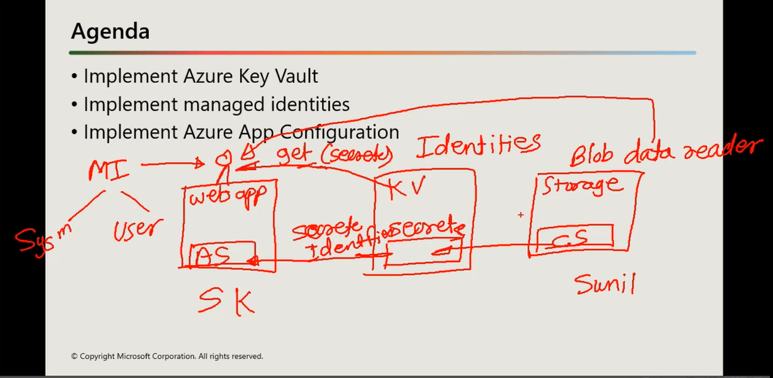

* [Managed identities for Azure resources](https://learn.microsoft.com/en-us/azure/active-directory/managed-identities-azure-resources/overview): When you deploy an app on a virtual machine in Azure, you can assign an identity to your virtual machine that has access to Key Vault. You can also assign identities to [other Azure resources](https://learn.microsoft.com/en-us/azure/active-directory/managed-identities-azure-resources/overview). The benefit of this approach is that the app or service isn't managing the rotation of the first secret. Azure automatically rotates the identity. We recommend this approach as a best practice.

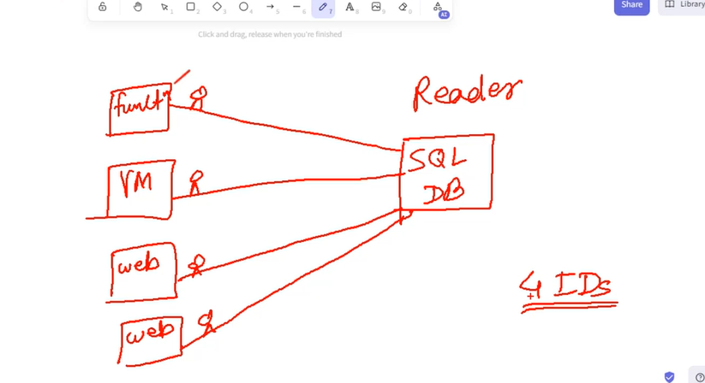

Using system defined managed identity, we provides separate identity to every resource to access Sql DB resources.

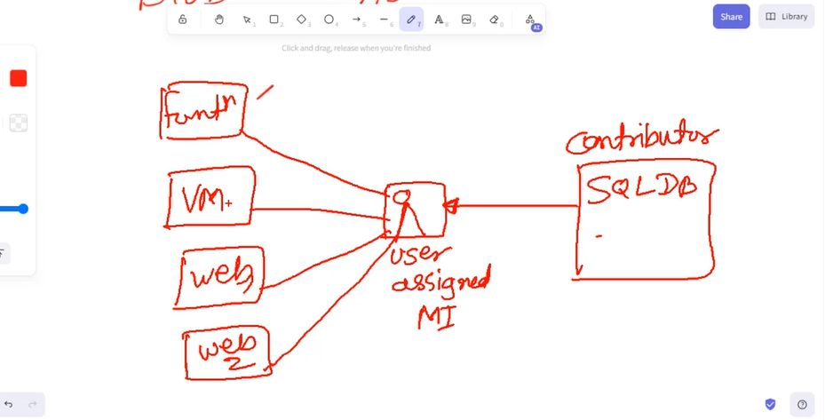

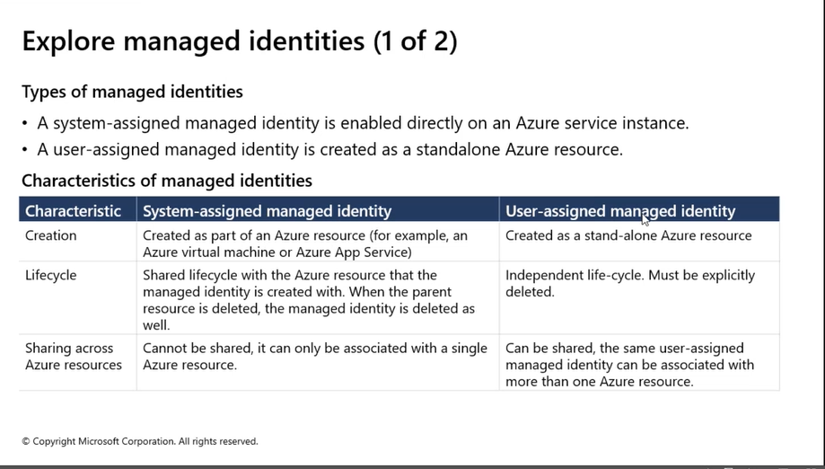

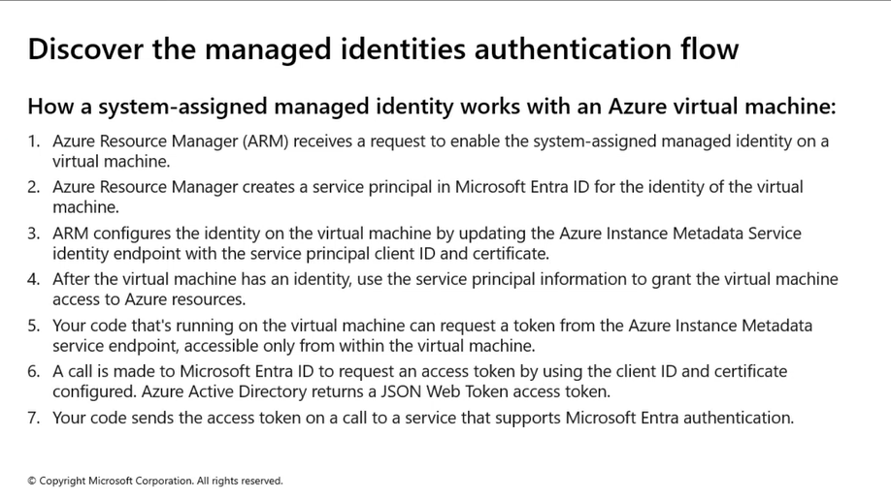

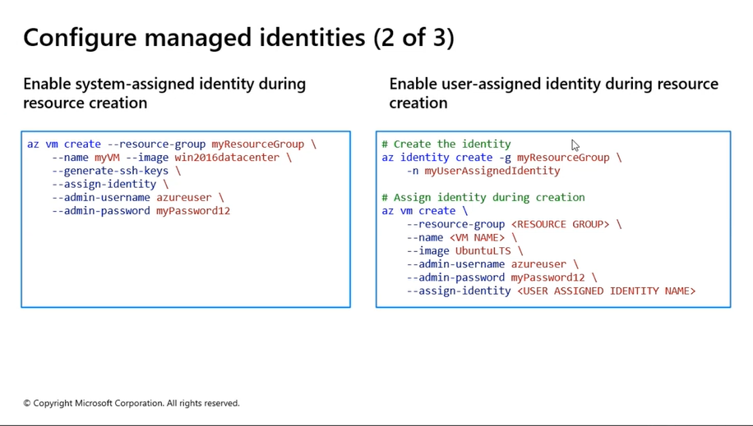

What is the difference between Azure key vault and configuration manager?

Azure Key Vault is a powerful solution for storing, accessing, and managing secrets. Azure App Configuration keys can reference values stored in Key Vault. Key Vault Reference contains URI pointing to the Key Vault secret; it does not contain the actual secret value.